**PF Lab Assignment 05**

**Problem 1:**

**Write a program that categorizes a person's age into different life stages: Child, Teenager, Adult, and Senior, using nested if-else statements.**

**Source code:**

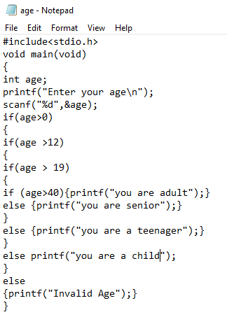

**Output code:**

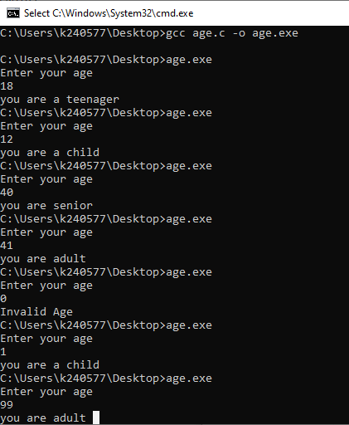

**Problem 2:**

**Create a program that determines if a number is positive, negative, or zero, and if it’s positive,**

**checks if it’s an even or odd number.**

**Source code:**

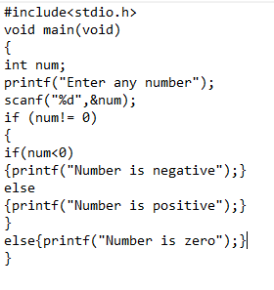

**Output:**

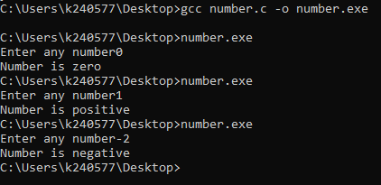

**Problem 3:**

**Write a program that checks if a number is divisible by both 3 and 5 using logical operators.**

**Source code:**

**Problem 4:**

**Create a program that checks if a person is eligible to vote based on their age and citizenship status.**

**Source code:**

**Output:**

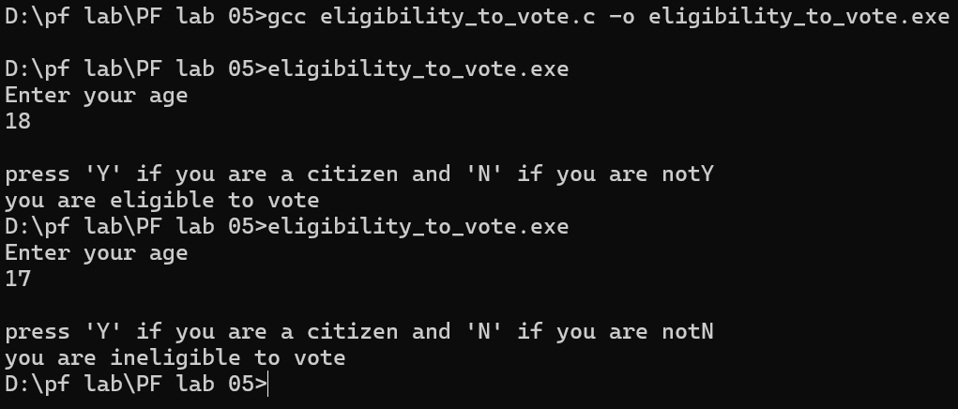

**Problem 5:**

**Write a program using a ternary operator to find the maximum of two numbers.**

**Source code:**

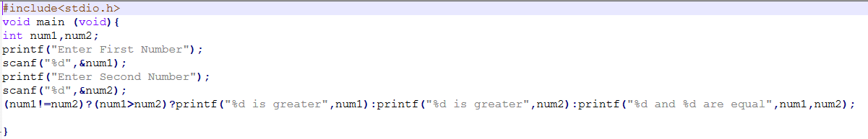

**Output:**

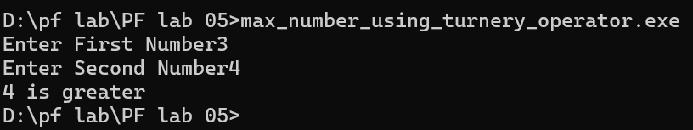

**Problem 6:**

**Use the ternary operator to check if a number is positive, negative, or zero.**

**Source code:**

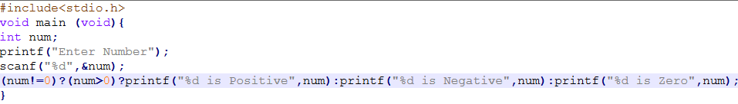

**Output:**

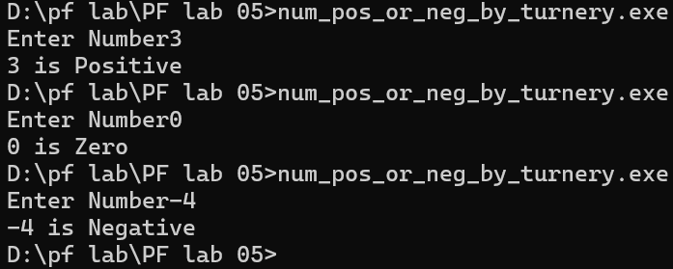

**Problem 7:**

**Write a program to swap two numbers using bitwise XOR.**

**Source code:**

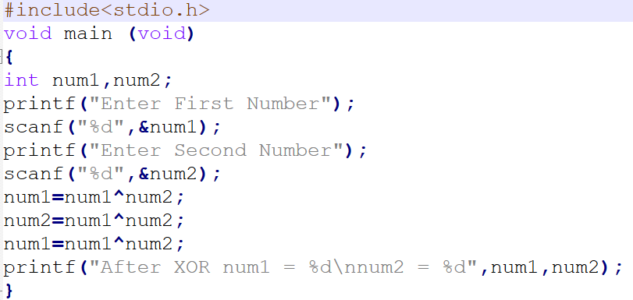

**Output:**

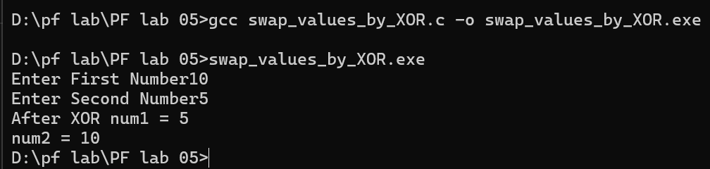

**Problem 8:**

**Write a program that checks if a year is a leap year using the modulus operator.**

**Source code:**

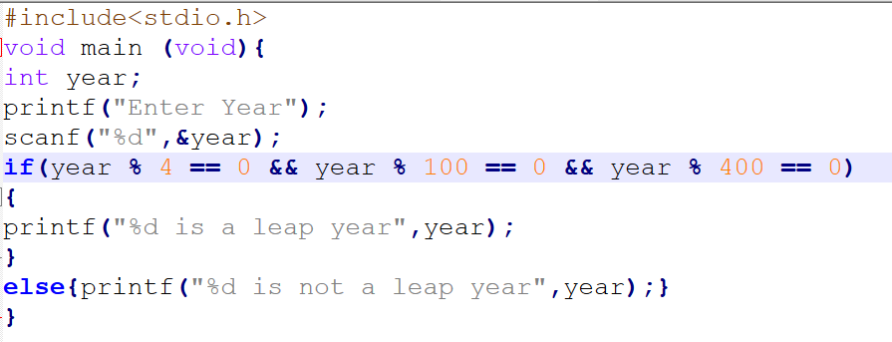

**Output:**

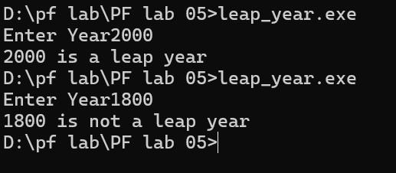

**Problem 9:**

**Write a program to find the greatest of three numbers using nested if-else statements.**

**Source code:**

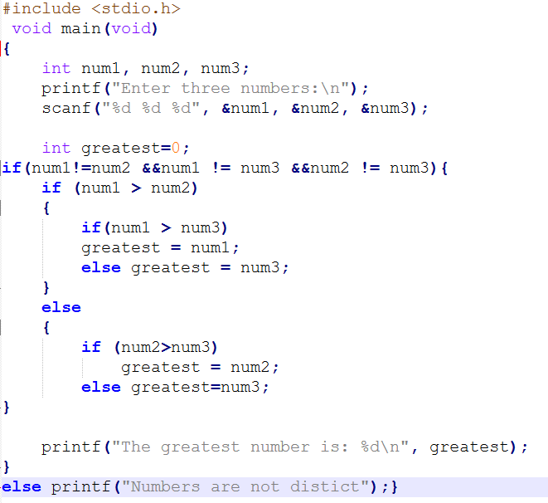

**Output:**

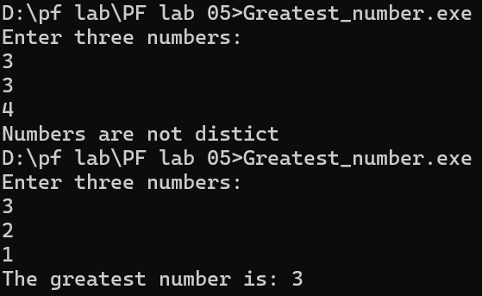

**Problem 10:**

**Create a program that calculates the final grade of a student based on multiple criteria, including attendance, assignment scores, and exam results, using nested decision structures.**

**Source code:**

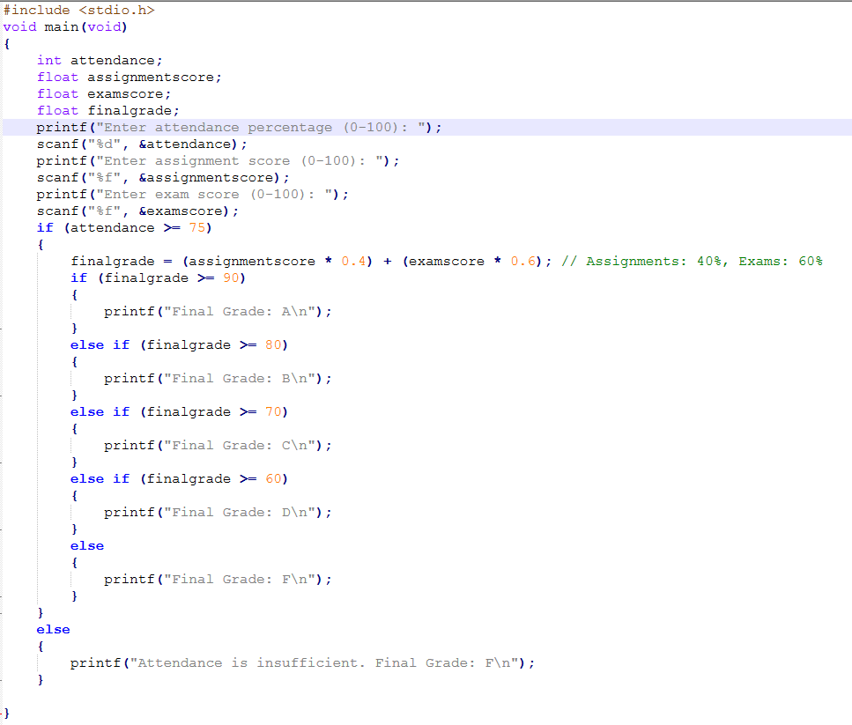

**Output:**

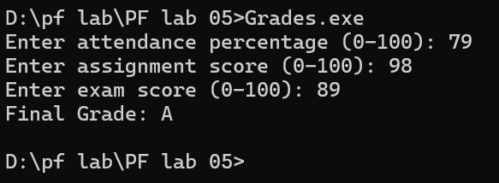

**Problem 11:**

**Write a program that uses bitwise operators to perform encryption and decryption of a character.**

**Source code:**

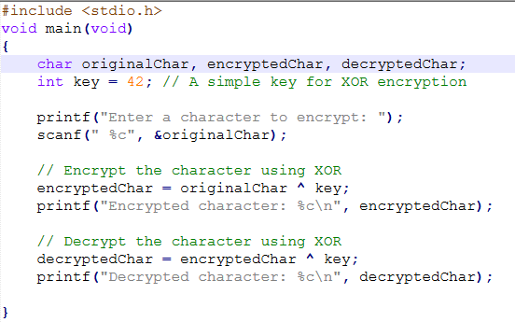

**Output:**

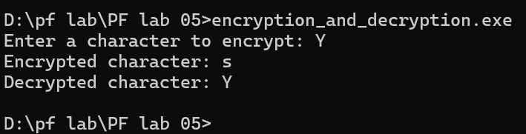

**Problem 12:**

**Develop a program that uses logical operators to determine if a person is eligible for a loan based on age, income, and credit score.**

**Source code:**

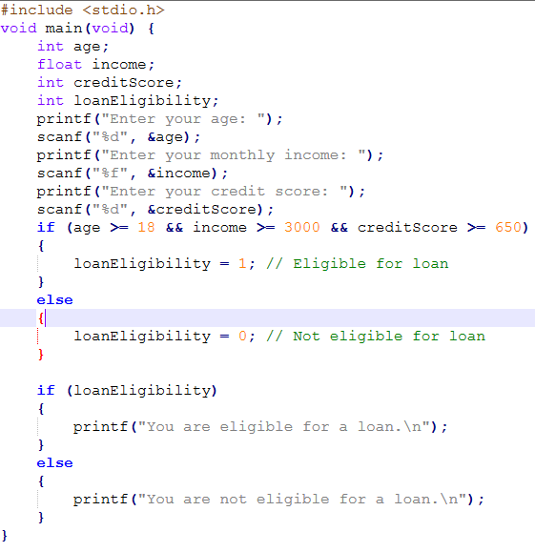

**Output:**

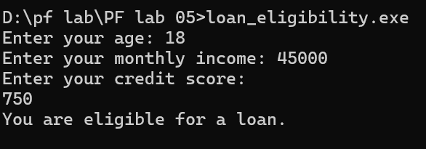

**Problem 4:**

**Source code:**

**Output:**